Assignment 2

21_AIE_203

Data Structure and Algorithms – SEM-III

Professor – Dr. Sachin Sir

Submitted By: Vikhyat Bansal [CB.EN.U4AIE21076]



Q1. Implement Breadth-First Search using Recursion.

Code:

package *SEM_3_Assign_2*;

import *java*.*util*.*\**;

// *breadth first search in graph using adjacency list WITH RECURSION*

import *java*.*util*.*\**;

*class* RecurBFS

{

    // *Perform BFS recursively on the graph*

*public* *static* void *recursiveBFS*(Graph graph, Queue<Integer> q,

                                    boolean[] discovered)

    {

*if* (q.*isEmpty*()) {

*return*;

        }

        // *dequeue front node and print it*

        int v = q.*poll*();

        System.*out*.*print*(v + " ");

        // *do for every edge (v, u)*

*for* (int u*:* graph.*adjList*.*get*(v))

        {

*if* (!discovered[u])

            {

                // *mark it as discovered and enqueue it*

                discovered[u] = true;

                q.*add*(u);

            }

        }

*recursiveBFS*(graph, q, discovered);

    }

*public* *static* void *main*(String[] args)

    {

        // *List of graph edges as per the above diagram*

        List<Edge> edges = Arrays.*asList*(

*new* *Edge*(1, 2), *new* *Edge*(1, 3), *new* *Edge*(1, 4), *new* *Edge*(2, 5),

*new* *Edge*(2, 6), *new* *Edge*(5, 9), *new* *Edge*(5, 10), *new* *Edge*(4, 7),

*new* *Edge*(4, 8), *new* *Edge*(7, 11), *new* *Edge*(7, 12),*new* Edge

                (3,13),*new* *Edge*(3,14)

        );

        // *total number of nodes in the graph (labelled from 0 to 14)*

        int n = 15;

        // *build a graph from the given edges*

        Graph graph = *new* *Graph*(edges, n);

        // *to keep track of whether a vertex is discovered or not*

        boolean[] discovered = *new* boolean[n];

        // *create a queue for doing BFS*

        Queue<Integer> q = *new* ArrayDeque<>();

        // *Perform BFS traversal from all undiscovered nodes to*

        // *cover all connected components of a graph*

*for* (int i = 0; i < n; i++)

        {

*if* (discovered[i] == false)

            {

                // *mark the source vertex as discovered*

                discovered[i] = true;

                // *enqueue source vertex*

                q.*add*(i);

                // *start BFS traversal from vertex `i`*

*recursiveBFS*(graph, q, discovered);

            }

        }

    }

}

// *A class to store a graph edge*

*class* Edge

{

    int source, destin;

*public* *Edge*(int source, int destin)

    {

        this.*source* = source;

        this.*destin* = destin;

    }

}

// *A class to represent a graph object*

*class* Graph

{

    // *A list of lists to represent an adjacency list*

    List<List<Integer>> adjList = null;

    // *Constructor*

*Graph*(List<Edge> edges, int n)

    {

        adjList = *new* ArrayList<>();

*for* (int i = 0; i < n; i++) {

            adjList.*add*(*new* ArrayList<>());

        }

        // *add edges to the undirected graph*

*for* (Edge edge*:* edges)

        {

            int src = edge.*source*;

            int destin = edge.*destin*;

            adjList.*get*(src).*add*(destin);

            adjList.*get*(destin).*add*(src);

        }

    }

}

Explanation:

* We are creating two classes which will help us in creating Graph data structure namely Edge and Graph.
* Now, we are going to create a class for Recursive BFS, which will contain a function for recursiveBFS.
* In method recursiveBFS, it will check whether the queue is empty or not.
* Then, accordingly it will visit each node and then after visiting each node it will mark it as discovered and then enqueue it in a queue where it will get marked and printed.
* This method will recursively call itself until and unless the queue is empty and as soon as queue is empty, it will stop the method.
* Now, we will create the MAIN method where we will create an adjacency list and then call the function/method which will mention all the nodes after traversing.

OUTPUT:



Q2. Implement Breadth-First Search without using Recursion.

Code:

package *SEM_3_Assign_2*;

// *breadth first search in graph using adjacency matrix WITHOUT RECURSION*

import *java*.*util*.*\**;

*public* *class* BFSworecur {

*static* int[][] mat = *new* int[4][4];

*static* int[] visited = *new* int[4];

*static* int[] queue = *new* int[4];

*static* int front = 0;

*static* int rear = 0;

*static* int count = 0;

*static* void *insert*(int x){

        queue[rear] = x;

        rear++;

        count++;

    }

*static* int *delete*(){

        int x = queue[front];

        front++;

        count--;

*return* x;

    }

*static* void *bfs*(int v){

        int i;

        visited[v] = 1;

*insert*(v);

*while*(count!=0){

            v = *delete*();

            System.*out*.*print*((v+1) + " ");

*for* (i = 0;i<4;i++){

*if* (mat[v][i] == 1 && visited[i] == 0){

*insert*(i);

                    visited[i] = 1;

                }

            }

        }

    }

*public* *static* void *main*(String[] args) {

        mat[0][1] = 1;

        mat[0][2] = 1;

        mat[1][0] = 1;

        mat[1][2] = 1;

        mat[2][0] = 1;

        mat[2][1] = 1;

        mat[2][3] = 1;

        mat[3][2] = 1;

        System.*out*.*println*("The adjacency matrix is: ");

*for* (int i = 0;i<4;i++){

*for* (int j = 0;j<4;j++){

                System.*out*.*print*(mat[i][j] + " ");

            }

            System.*out*.*println*();

        }

        System.*out*.*println*("The BFS traversal is: ");

*bfs*(2);

}

}

Explanation:

* We have created a public class for breadth first without recursion.
* We have initialized 1-D array which will act as QUEUE and 2-D array which will act as adjacency matrix for representing GRAPH. Taking some variables that will do working of QUEUE functions.
* Finally, a method for BFS is created which will visit the node connected to the vertex and then we will insert the values in QUEUE which were never visited and then after visiting once those once visited vertex will get dequeued.
* Finally, MAIN is created where we will call the methods.

OUTPUT:

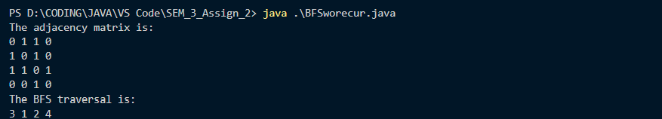

Q3. Implement Depth-First Search using Recursion.

CODE:

package *SEM_3_Assign_2*;

// *depth first search in graph using adjacency matrix WITH RECURSION*

*public* *class* RecurDFS {

*static* int[][] mat = *new* int[4][4];

*static* int[] visited = *new* int[4];

*static* void *dfs*(int v){

        int i;

        visited[v] = 1;

        System.*out*.*print*((v+1) + " ");

*for* (i = 0;i<4;i++){

*if* (mat[v][i] == 1 && visited[i] == 0){

*dfs*(i);

            }

        }

    }

*public* *static* void *main*(String[] args) {

        mat[0][1] = 1;

        mat[0][2] = 1;

        mat[1][0] = 1;

        mat[1][2] = 1;

        mat[2][0] = 1;

        mat[2][1] = 1;

        mat[2][3] = 1;

        mat[3][2] = 1;

        System.*out*.*println*("The adjacency matrix is: ");

*for* (int i = 0;i<4;i++){

*for* (int j = 0;j<4;j++){

                System.*out*.*print*(mat[i][j] + " ");

            }

            System.*out*.*println*();

        }

        System.*out*.*println*("The depth first search is: ");

*dfs*(2);

    }

}

Explanation:

* Creating a class RecurDFS which will initialize a matrix and an array which will store all visited nodes.
* A method named dfs is created which will take argument as int v that is the node number.
* After each node is being visited, it is stored in the array and then printed.
* Finally, MAIN class is created which will call the dfs method for traversal.

OUTPUT:

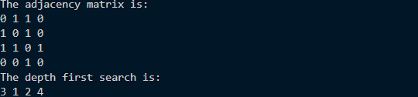

Q4. Implement Depth-First Search without Recursion.

CODE:

package *SEM_3_Assign_2*;

// *depth first search in graph using adjacency matrix WITHOUT RECURSION*

*public* *class* DFSworecur {

*static* int[][] mat = *new* int[4][4];

*static* int[] visited = *new* int[4];

*static* int[] stack = *new* int[4];

*static* int top = -1;

*static* int count = 0;

*static* void *push*(int x){

        stack[++top] = x;

        count++;

    }

*static* int *pop*(){

        int x = stack[top--];

        count--;

*return* x;

    }

*static* void *dfs*(int v){

        int i;

        visited[v] = 1;

*push*(v);

*while*(count!=0){

            v = *pop*();

            System.*out*.*print*((v+1) + " ");

*for* (i = 0;i<4;i++){

*if* (mat[v][i] == 1 && visited[i] == 0){

*push*(i);

                    visited[i] = 1;

                }

            }

        }

    }

*public* *static* void *main*(String[] args) {

        mat[0][1] = 1;

        mat[0][2] = 1;

        mat[1][0] = 1;

        mat[1][2] = 1;

        mat[2][0] = 1;

        mat[2][1] = 1;

        mat[2][3] = 1;

        mat[3][2] = 1;

        System.*out*.*println*("The adjacency matrix is: ");

*for* (int i = 0;i<4;i++){

*for* (int j = 0;j<4;j++){

                System.*out*.*print*(mat[i][j] + " ");

            }

            System.*out*.*println*();

        }

        System.*out*.*println*("The depth first search is: ");

*dfs*(2);

    }

}

Explanation:

* We have created a public class for depth first without recursion.
* We have initialized 1-D array which will act as STACK and 2-D array which will act as adjacency matrix for representing GRAPH. Taking some variables that will do working of STACK functions.
* Finally, a method for DFS is created which will visit the node connected to the vertex and then we will insert the values in STACK which were never visited and then after visiting once those once visited vertex will get popped.
* Finally, MAIN is created where we will call the methods.

OUTPUT:

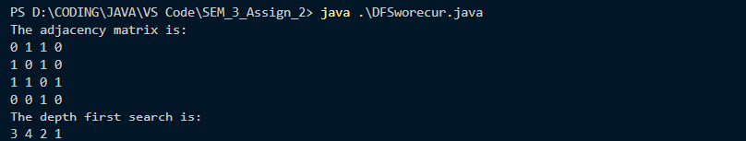

THANK YOU